KINDLY SPONSORED BY ‘THE NORTHERN SNOOKER CENTRE’

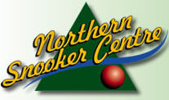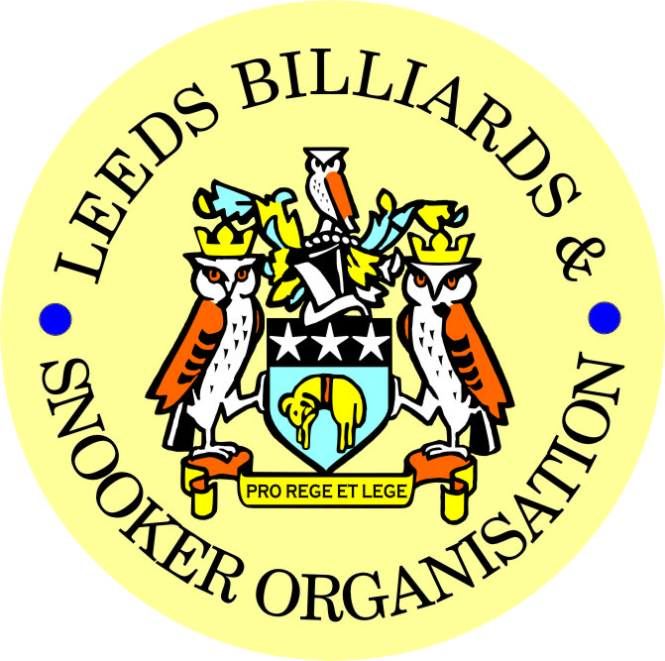

**2016-2017 PRIZE PRESENTATION EVENING**
**WEDNESDAY 19th JULY 2017**
** HAREHILLS LABOUR CLUB**

A WARM WELCOME TO EVERYBODY!

FIRSTLY – A FEW THANK YOU’s TO-
- NORTHERN SNOOKER CENTRE – FINANCIAL SUPPORT & USE OF THE NSC
- HAREHILLS LABOUR, FARSLEY CONS & HORSFORTH CONS – STAGING OF SEMI-FINALS & FINALS OF LBSO 2 TABLE TEAM EVENTS
- ALL REFEREES – WHO HAVE OFFICIATED THIS YEAR
- ALL COMMITTEE MEMBERS – ANOTHER BUSY & HARD WORKING YEAR
- HOLBECK WMC – DELEGATE MEETINGS
- ALL DELEGATES WHO HAVE ATTENDED MEETINGS
- HAREHILLS LABOUR CLUB – COMMITTEE AND MEMBERS ALLOWING US TO STAGE TONIGHT’s EVENT

** LEEDS CITY CHAMPIONSHIPS - JUNIORS **
U.16’s & U.18’s – SNOOKER – (Scratch)

UNDER 16’s SNOOKER:
Presented by ADT Flexibles (UK) Ltd.
WINNER: SAMUEL LEE-STEVENS | RUNNER-UP: DANIEL BOYES
SEMI-FINAL: JOSH BRADY | SEMI-FINAL: ISA ISHTIAQ
UNDER 18’s SNOOKER:
“The Keith Weston Memorial Trophy”- Presented by ADT Flexibles (UK) Ltd.
WINNER: LEWIS HARPER | RUNNER-UP: SAMUEL LEE-STEVENS
SEMI-FINAL: CHARLIE SMITH | SEMI-FINAL: BAILEY FISHER
JUNIOR HIGH BREAK: - “The Paul Hunter Memorial Trophy” – ISA ISHTIAQ

** LEEDS CITY CHAMPIONSHIPS **
(Scratch)
INDIVIDUAL SNOOKER:
WINNER: PETER LINES | RUNNER-UP: SCOTT RAPER
SEMI-FINAL: DANIEL WOMERSLEY | SEMI-FINAL: IAN O’BRIEN
PAIRS SNOOKER:
Trophy - Presented by ADT Flexibles (UK) Ltd.
WINNERS: J.BAGLEY / P.LINES | RUNNERS-UP: A.MASSEY / S.RAPER
SEMI-FINAL: C.HART / S.BROADHEAD | SEMI-FINAL: I.RAYNER / J.BRAITHWAITE
TEAM SNOOKER – “The Jim Fowler’s Trophy”:
WINNERS: HORSFORTH CONS | RUNNERS-UP: CROSSGATES REC HALL
SEMI-FINAL: BEESTON SPORTS & SOCIAL | SEMI-FINAL: MAIN LINE SOCIAL

SNOOKER - “Veterans Trophy” | REFEREES:  Officiated in 2016-17 LBSO Competitions:
WINNER: PETER HALL | MARK KING
RUNNER-UP: PAUL GRIMES | ALEX CRUM
PLATE WINNER: PETER O’CONNELL | KENNETH SYMONS
PLATE RUNNER-UP: GARRY PAYNE | PETER WALKER
 | BOB PATTERSON

Break for Entertainment – MAIN PRESENTATION to follow afterwards:
ALSO - PRESENTATION OF SPECIAL AWARDS – To be announced LATER!

** LBSO - BILLIARDS & SNOOKER LEAGUES **

Div: | CUP TITLE / WINNERS: | RUNNERS-UP:
Billiards | The Yorkshire Evening News Cup:  ROWLAND ROAD WMC | LPSA
Div A | The Yorkshire Evening News Shield:  EXCELSIOR S.C. ‘B’ | BRAMLEY BAND ‘B’
Div B | The Clan Tartan Trophy:  EXCELSIOR S.C. ‘A’ | NORTHERN S.C. ‘C’
Div C | The John Dunning Trophy:  NEW MOORSIDE | GILDERSOME CONS ‘B’
Div D | The J. H. Lunn Cup:  TINSHILL & COOKRIDGE ‘B’ | CORPUS CHRISTI ‘B’
Div E | The Peter Nelson Trophy:  CROSSGATES REC HALL ‘B’ | HAREHILLS LABOUR ‘A’
Div F | The Peter Hawkyard Memorial Trophy:  HORSFORTH CONS | HAREHILLS WMC ‘B’
Div G | The J. McDonnell / J. Williamson Trophy:  BELLE ISLE WMC ‘D’ | THE RAILWAY CLUB
Div H | The Keith Darley Trophy:  BEESTON SPORTS & SOCIAL | CHAPEL ALLERTON ‘A’

“CHAMPION of CHAMPIONS”  “The Jim Williamson Memorial Trophy”  Presented by the Northern Snooker Centre | WINNERS: EXCELSIOR S.C. ‘A’  (DIVISION B WINNERS)

LBSO LEAGUE - HIGHEST BREAKS – BILLIARDS & SNOOKER
Billiards ‘A’ – (-200 to +19) | TBA on the night
Billiards ‘B’ – (+20 to +200) | TBA on the night
Snooker – Group 1 (-80 to -20) | 139 & 136 – Michael Tomlinson (-25) – Northern Snooker Centre ‘A’
Snooker – Group 2 (-19 to +5) | 100 – Dave Watson (-9) – South Leeds Cons ‘A’
Snooker – Group 3 (+6 to +20) | 63 – Gary Hobbs (+20) – Horsforth Cons
Snooker – Group 4 (+21 to +30) | 59 – Tim Proctor (+22) – Bramley Villagers ‘A’
Snooker – Group 5 (+31 to +80) | 41 – Simon Clarke (+33) – Morley International

SNOOKER – Individual Handicap.
The “GEORGE SYKES CUP”
WINNER: STEVEN HIRST  (BELLE ISLE WMC) | RUNNER-UP: DAZ HUGHES  (HAREHILLS WMC)
SEMI-FINAL: MARK McGREAVY  (MORLEY CONS) | SEMI FINAL: KARL BRIGGS  (CROSSAGTES REC HALL)

SNOOKER – Pairs Handicap.
The “LEN LEE CUP”
WINNERS: D.BINNS & S.REYNOLDS  (MIDDLETON CONS) | RUNNERS-UP: R.ASPIN & M.ASPIN  (MIDDLETON CONS)
SEMI-FINAL: J.BELL & K.WALKER  (SWILLINGTON MINERS W.) | SEMI-FINAL: L.NICHOLSON & J.MULLEN  (BEESTON SPORTS & SOC.)

SNOOKER - 3 MAN TEAM KNOCK OUT – Handicap.
The “Leeds & District Billiards League Snooker Cup”
WINNERS: ROTHWELL WMC | RUNNERS-UP: LPSA
SEMI-FINAL: BELLES ISLE WMC | SEMI FINAL: HORSFORTH CONS

** STAN BROOKE MEMORIAL COMPETITIONS **
(AGGREGATE SCORES)
INDIVIDUAL SNOOKER – 3 FRAMES:
WINNER: JULIAN KEEGAN  (GILDESOME CONS) | RUNNER-UP: JOHN REA  (EAST END PARK WMC)
SEMI-FINAL: DANIEL GRIMES  (MORLEY WMC & INST) | SEMI FINAL: MICHAEL GAUGHAN  (GILDERSOME CONS)
PAIRS SNOOKER – 3 FRAMES:
WINNERS: S. HIRST & S. FELL  (BELLE ISLE WMC) | RUNNER-UP: D.GALE & D.DEAN  (NEW MIDDLETON)
SEMI-FINAL L.GRIMES & P.GRIMES  (MORLEY WMC & INST) | SEMI-FINAL: M.SAVERY & P.GOODALL  (NEW HEADINGLEY)
TEAM SNOOKER – 4 FRAMES:
WINNERS: BRAMLEY VILLAGERS | RUNNERS-UP: DRIGHLINGTON T.C. CLUB
SEMI-FINAL: BARNBOW SOCIAL CLUB ‘B’ | SEMI-FINAL: HAREHILLS LIBERAL CLUB

LEN LEE INVITATION SNOOKER – (Scratch):  “THE LEN LEE TROPHY” | WINNER: RYAN WALTON  RUNNER-UP: LEE ATKINSON  SEMI-FINAL: LEWIS GILLEN  SEMI-FINAL: JASON BRAITHWAITE

The “WINDSOR TROPHY” – 4 Man Team Handicap
Presented by ADT Flexibles (UK) Ltd.
WINNERS: GILDERSOME CONS | RUNNERS-UP: HAREHILLS LABOUR
SEMI-FINAL: ROWLAND ROAD WMC | SEMI FINAL: NEW WORTLEY LABOUR

CONGRATULATIONS!
TO ALL PRIZE WINNERS FOR 2016-17

The LBSO would like to thank again the Committee and Members of
The Harehills Labour Club for staging this year’s Presentation Night.

Annual General Metting - AGM.

MONDAY 4th SEPTEMBER 2017 – 7-45pm
at
HOLBECK WMC

CURRENT COMMITTEE MEMBERS
PRESIDENT – CHRIS WILLIAMSON
CHAIRMAN – ANDY TAFFINDER
VICE CHAIRMAN – RODNEY SIMS
LEAGUE SECRETARY – PAUL GRIMES
COMPETITION SECRETARIES – MARK BALL & PAUL MARLOW
GENERAL SECRETARY / TREASURER – BOB PATTERSON

The LBSO would like to thank the Committee and Members of Holbeck WMC, for allowing us the use of the club for LBSO delegate meetings and the AGM, throughout this season and in the past.

OTHER DATES:
4th September 2017 (AGM) – ALSO Scorebook Collection,
6th September 2017 – START OF LEAGUE SEASON

Produced By

Kindly Sponsored by the ‘NORTHERN SNOOKER CENTRE’

